Food That Magically Regrows Itself from Kitchen Scraps

Let’s face it, eating well is expensive. Luckily, you can save a few bucks off your grocery bill by growing a few of those staples from your diet. Best part, it is much easier than you think. You don’t need seeds or anything fancy. You can simply use kitchen scraps from your next meal. Check out this infographic to learn how to grow food from kitchen scraps.

[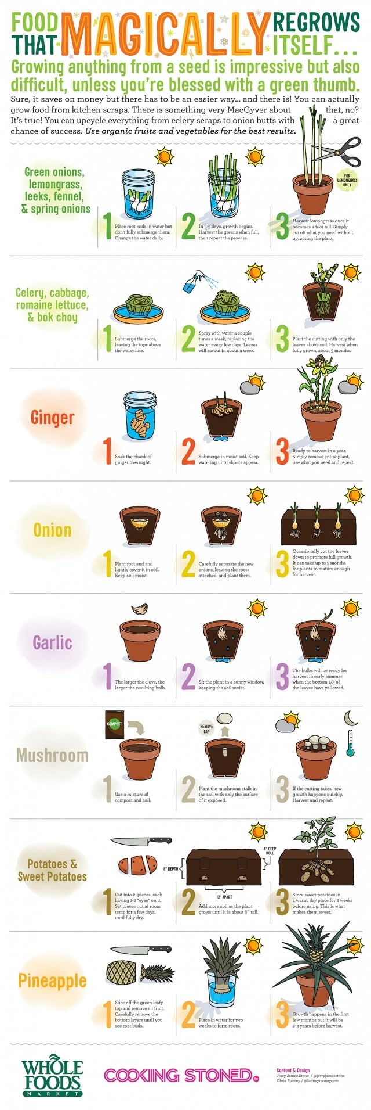](https://balconygardenweb-lhnfx0beomqvnhspx.netdna-ssl.com/wp-content/uploads/2016/06/regrow-food-from-kitchen-scraps-infographic-1.jpg)